Specializing In
- Periodontics
- Holistic Dentistry
- Children’s Dentistry
- Hi-Tech Oral Hygiene Los Angeles, California

Dr. Morehead

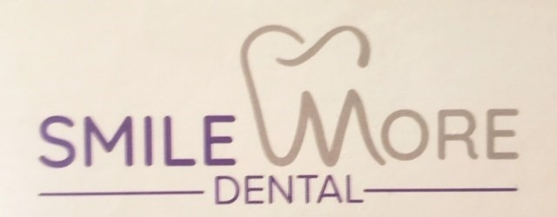
RSVP TODAY for SMILE MORE DENTAL WORLDWIDE VIRTUAL TOUR AND OPEN HOUSE Saturday,
June 20, 2020 11am-4pm (PST) / 310) 645-8777. “Watch Live TV” on www.SmileMore-Dental.com -
click the TV button. The first twenty people will receive entertainment discount coupons, Mobile USA/Canada app., with $100’s of dollars in hotel, travel, dining, entertainment and car rental dis- counts, and more. Sponsored and Produced by iOn Live Radio (800) 701-4562.
SOLUTION: The answer to the health and wellness issues peo- ple are facing are digital. Espe- cially sense everyone has a cell phone. CELL PHONE APP.
- Personal Medical Profile
- Results & Solutions
- Health and Wellness
- Professionals Direct & more
A team of doctors, dentists, psycholo- gist, attorneys, spiritual counselors etc.
“in the palms of your hands.”
Call for details. (310) 645-8777
PROBLEM: Maneuvering through the medical world is difficult at best; during the COVD-19 pandemic.
People are dying during the pan- demic from other illnesses because they can’t get adequate healthcare.
Psychologist cannot physically meet face to face with the patients, who need them desperately.
The chronically ill and elderly are unable to meet regularly with their healthcare professionals.
Watch Dr. Morehead’s TV
NOW
Listen to Dr. Morehead’s Radio
NOW

UNIQUENESS

Never Been Done!

Professional advice,
“in the palms of
your hands”.

TARGET MARKET: Healthcare professionals, Wellness industry and Everyday people.

COMING SOON!!!
DR. KEISHA MOREHEAD, DDS MULTI-MEDIA NETWORKS
- DIGITAL TV NETWORK - DIGITAL NEWSLETTERS - DIGITAL SHOPPING MALL - NUTRITION & WELLNESS SUPPLEMENTS

FOR MORE INFORMATION PLEASE CONTACT: SMILE MORE DENTAL. (310) 645.8777 www.Smilemore-Dental.com
© 2019 all rights reserved by its founder, creator, innovators, writers, developers and marketing, no copying, duplications or transferring without the expression permis- sion of its ownerships Smile More Dental/Dr. K Morehead DDS and iOn Global Networks / 1 800 701 4562 . /iOnTVWorld@gmail.com. iOn Global Networks, Inc. retains proprietary developers, global marketing, mobile apps, innovations, writers, administration and management.

